P O Box 220, Booval Qld 4304 Ph: 0409 754 884
Website: http://www.ipswichathletics.org.au

Newsletter 29th March 2018

President’s Message:

The Australian Track and Field Athletics Championships held in Sydney showed that our athletes can compete with the best. Congratulations to all those who competed but without the support of family and friends this would not happen. Well done coaches.

Don’t forget to nominate for a committee position as the AGM will be held on Sunday 20th May 2018 at Brothers Leagues Club at 10am. This day includes the Awards presentation.

Vic

Australian Junior Combined Events Championships
3rd & 4th March 2018, Lakeside Stadium, Melbourne

The club may have had only one competitor at these Championships, but Kiara Condon showed us how immense determination can win the Bronze medal in the U/15yrs Heptathlon, well done.

Kiara Condon U/15yrs Heptathlon 3667 points 3rd PB

Results of the seven events 90m Hurdles 15.39 2nd
High Jump 1.48m 1st
Shot Put 9.91m 1st
200m 30.04 4th
Long Jump 4.27m 4th
Javelin 26.88m 3rd
800m 2.47.32 4th PB
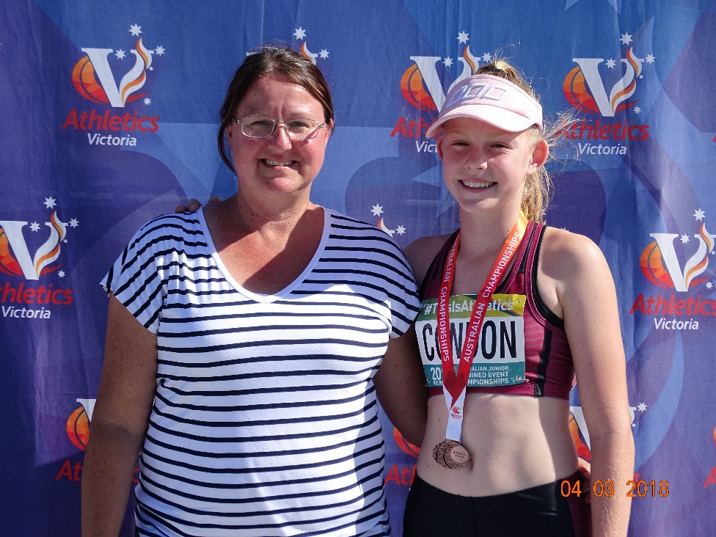

Proud mum Sharyn was so excited.

Sharyn & Kiara Condon
Coaches Theresa (Marty) Stolberg, Mark Sills and Michael Moore made it all happen, well done.

Australian Junior Track & Field Championships
14th March – 18th March 2018, Olympic Park, Sydney

Jessica Rowe U/14yrs Shot Put 11.12m 3rd PB
Discus 33.73m 2nd PB
Javelin 29.51m 6th
Hammer 34.10m 1st

Toby Stolberg U/14yrs High Jump 1.43m 10th

Erin Wright U/15yrs 90m Hurdles 13.26 3rd PB
200m Hurdles 28.81 1st PB

Camryn Novinetz U/16yrs 3000m Walk 14.58.95 5th

Laylani Vaai U/16yrs 90m Hurdles 14.92 22nd
Discus 36.39m 4th
U/17yrs Discus 35.57m 9th

Hayley Wright U/18yrs 100m Hurdles 13.90 4th PB (Heat 13.89) PB
100m 12.63 20th

Rochelle Vidler U/18yrs Hammer 62.79m 1st PB YOQ

Montanna McAvoy U/20yrs 3000m 10.10.23 1st PB WJQ
Steeple Chase
5000m 16.35.44 1st WJQ

Tyla Stolberg U/20yrs Shot Put 10.38m 12th

Cooper Farnsworth U/14yrs 100m 14.12 14th
QLD Team 4 x 100m Relay 54.16 3rd

Joshua Carrick U/16yrs 100m Hurdles 14.33 7th PB
200m Hurdles 27.27 7th PB
QLD Team 4 x 100m Relay 44.70 4th

Alex Davies U/17yrs 3000m 9.09.92 7th

Ryan Stewart U/17yrs 5000m Walk 29.41.10 12th

Jude Thomas U/17yrs 1500m 4.08.45 12th PB

Alexander Gough U/18yrs 3000m 9.09.97 18th (5th in Timed Final)
2000m 6.05.40 2nd PB
Steeple Chase

Benjamin Thomas U/18yrs 100m 10.88 5th PB
200m 22.12 2nd PB
QLD Team 4 x 100m Relay 42.12 2nd

With some really hot, windy and humid conditions happening, it was a fabulous result from a group of athletes with an excellent attitude along with supporting parents and coaches. I was so proud to watch their amazing performances, a great five days of competition where more than 2,000 athletes competed.
Montanna McAvoy just ran them off their legs as she won in convincing style as there was more than a 17 second buffer to the 2nd placegetter in the U/20yrs 5000m. In the U/20yrs 3000m Steeplechase again it was more than 16 seconds to the 2nd placegetter, each lap an ever increasing her lead in both races. It was marvellous to watch World Junior qualification times as these Championships are held in Tampere, Finland in July.

Rochelle Vidler was in a class of her own when winning the U/18yrs Hammer Throw with the 2nd placegetter more than 11m behind. Her speed and technique is something to behold, “Hurricane material”. Another Youth Olympic qualification, fantastic.

Erin Wright is a “little legend” as her peers stated after her win in the U/15yrs 200m Hurdles Final where even the commentator was stunned with her performance going on the heat times. This was then followed up with a wonderful performance to get the Bronze in the U/15yrs 90m Hurdles. In both races Erin came up with PB’s in heats and finals, absolutely brilliant.

Jessica Rowe was over the moon as this was her first nationals and to get two PB’s and a medal in three events was simply outstanding, an absolute gem in the making.

Alexander Gough was pushed to the limit when he won the Silver medal in the U/18yrs 2000m Steeplechase, a real gutsy effort after being pushed back to fourth position with a lap to go but he came home with a wet sail, exciting finish.

Benjamin Thomas exceeded my expectations when he took out the Silver medal in the U/18yrs 200m and then making the final of the U/18yrs 100m. Benjamin did something unthinkable and ran a PB in heats and finals of both races.

Just to get to this level is a marvelous achievement, but making it to be in the top 10 is magic.

A special thank you to all the parents, coaches and supporters of this wonderful club.

Below is a few pictures from Sydney. If you like them , just email me and I will send them out.

````````` Alicia, Montanna & Mark McAvoy
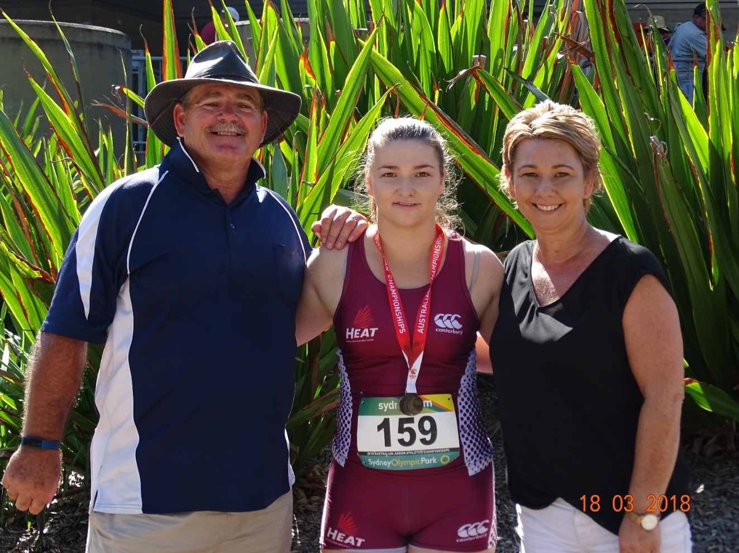

Coach Michael Moore Rochelle & Ann Vidler

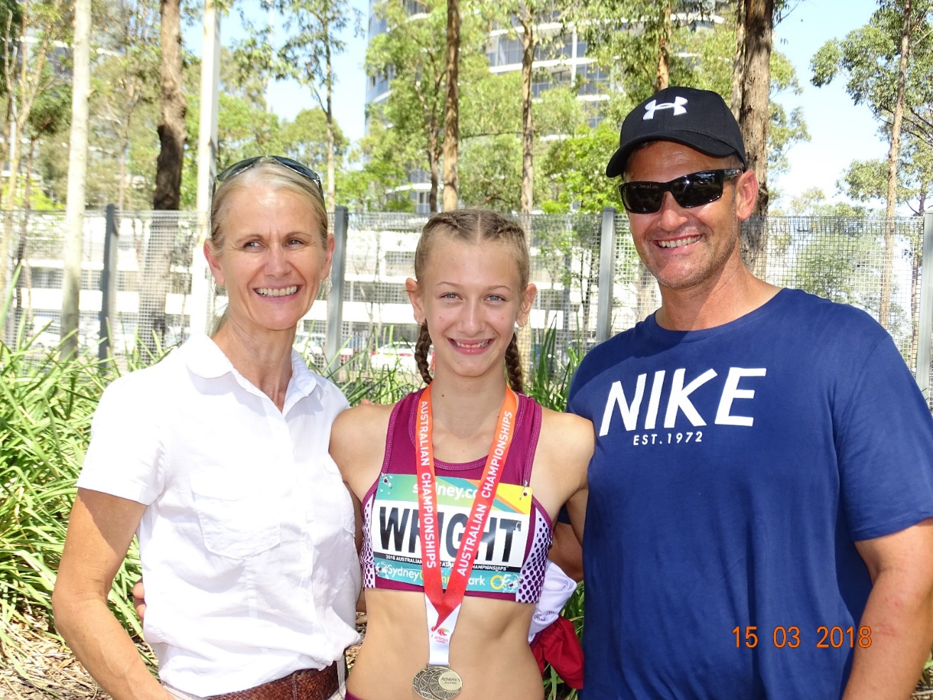

Vicki, Hayley, Erin & Coach David Wright

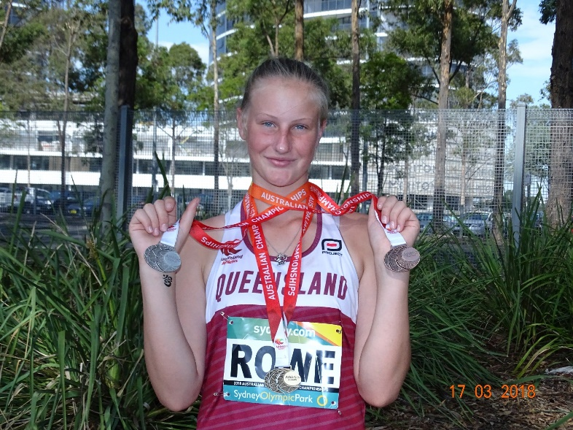
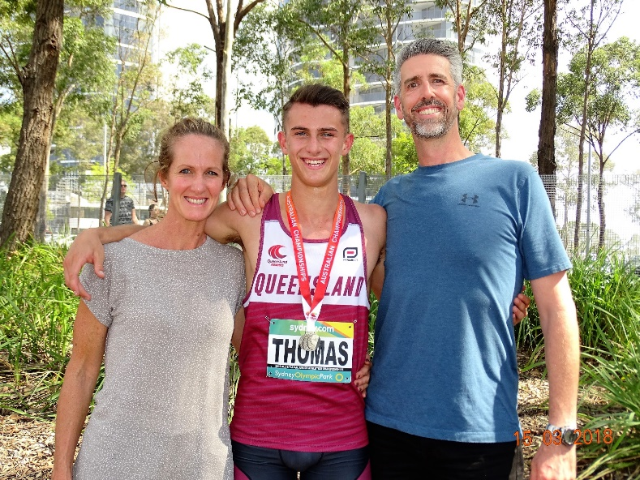

Tracey Biddell, Ben Thomas & Brett Biddell Jessica Rowe

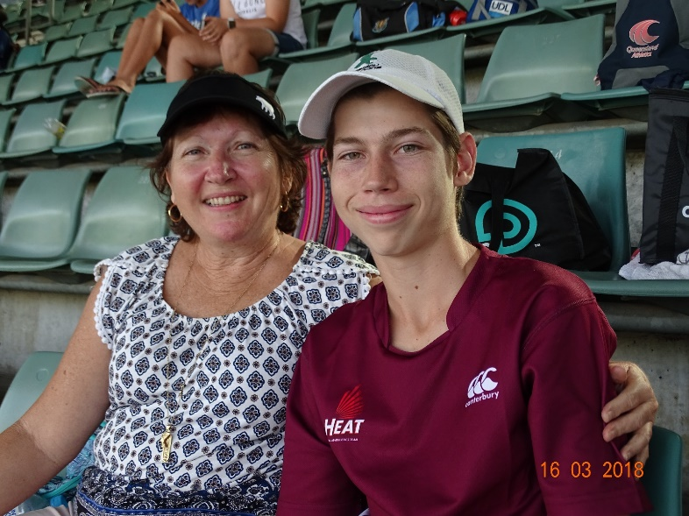
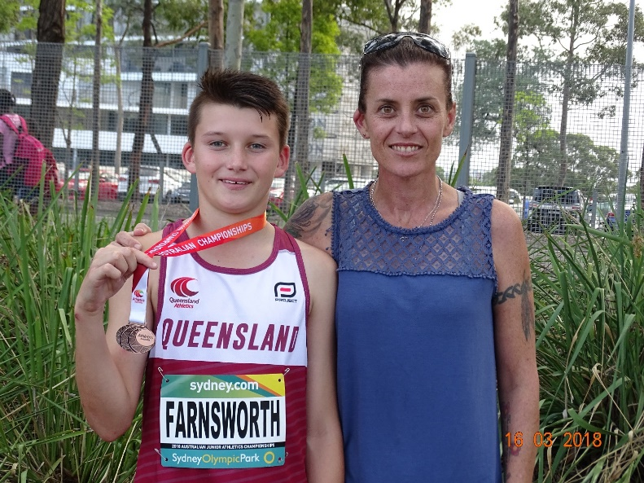

Cooper & Monica Farnsworth Megan Edkins & Alex Davies

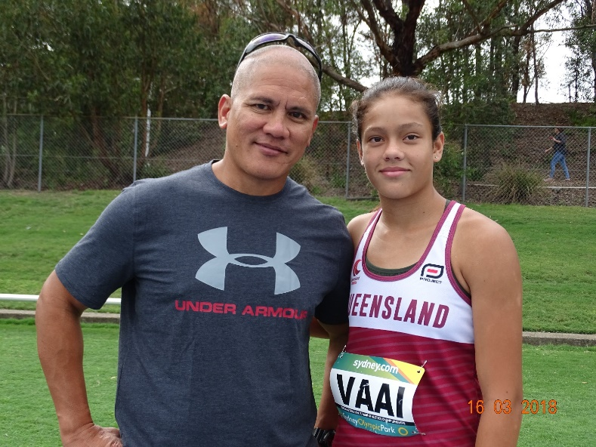
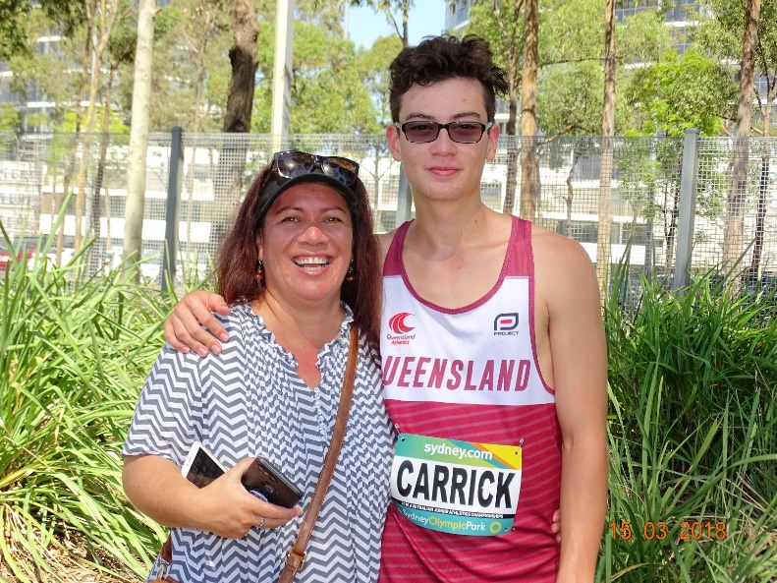

Rochelle & Joshua Carrick Willie & Laylani Va’ai

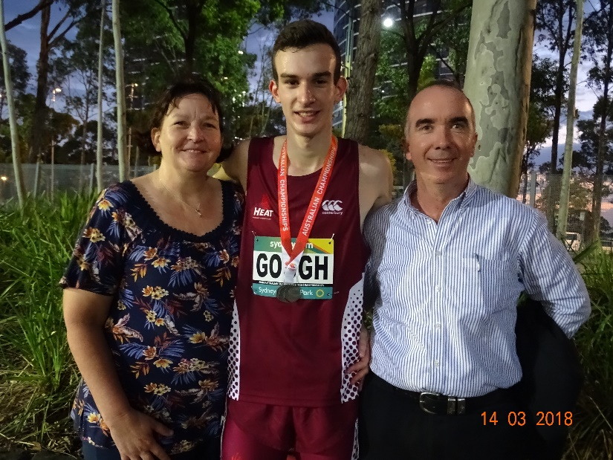
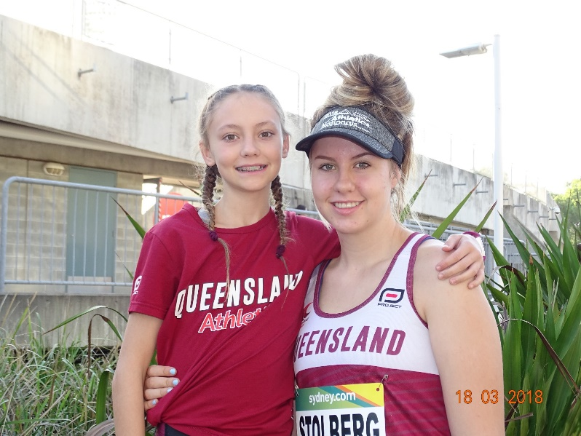

Karen, Alexander & Brendan Gough Toby & Tyla Stolberg

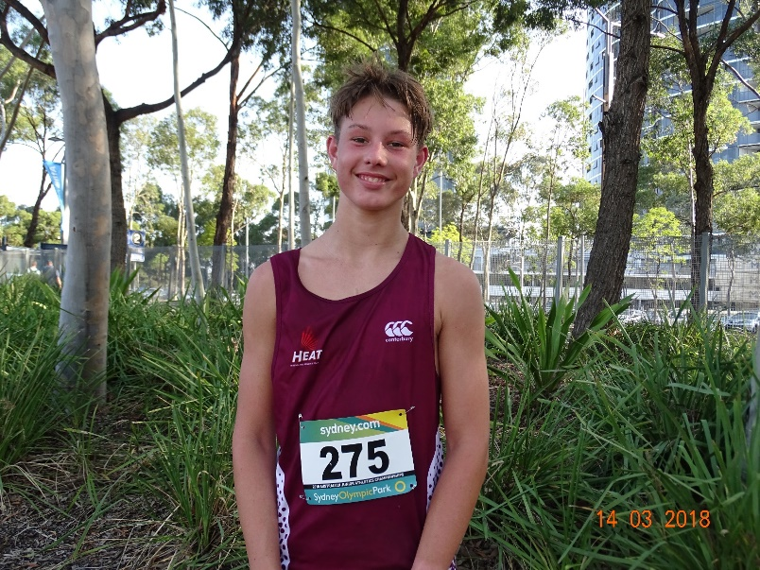

Ryan Stewart

Ryan’s Style

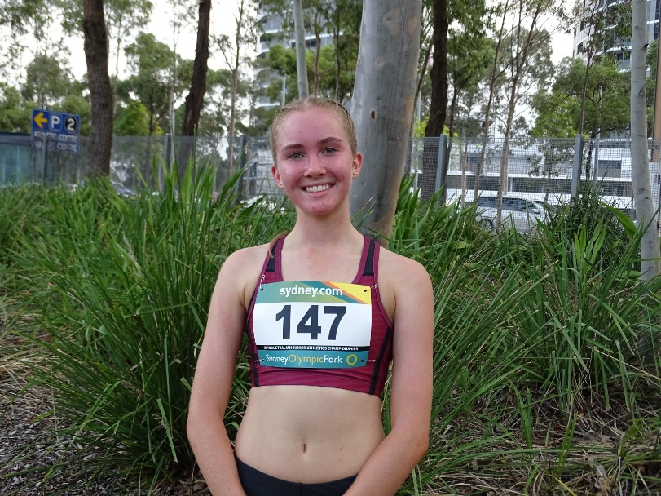
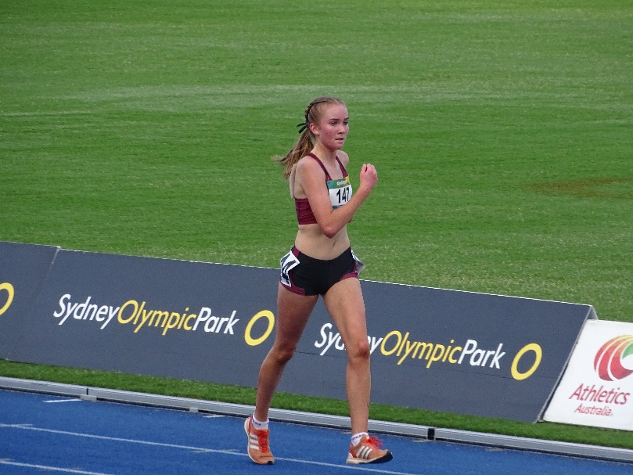

Camryn’s style

Camryn Novinetz

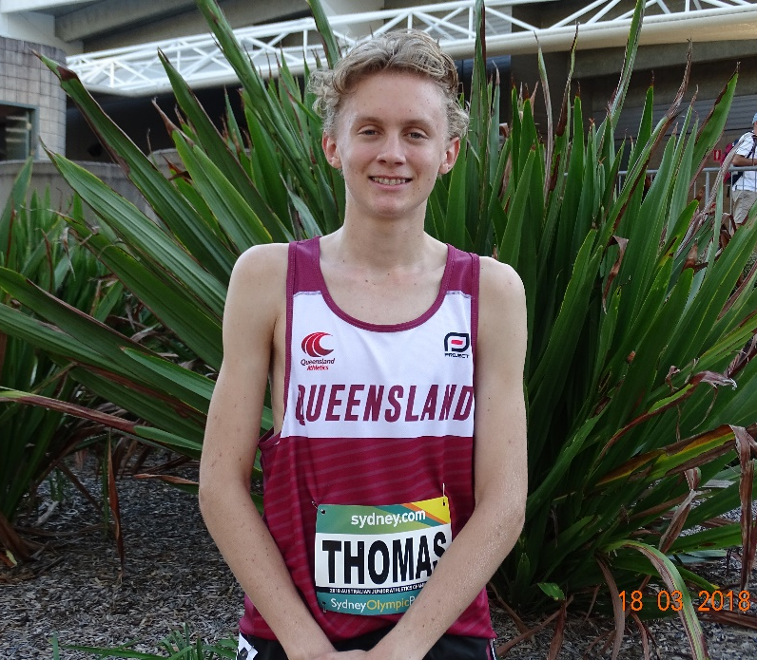

Jude Thomas “The flying Montanna”

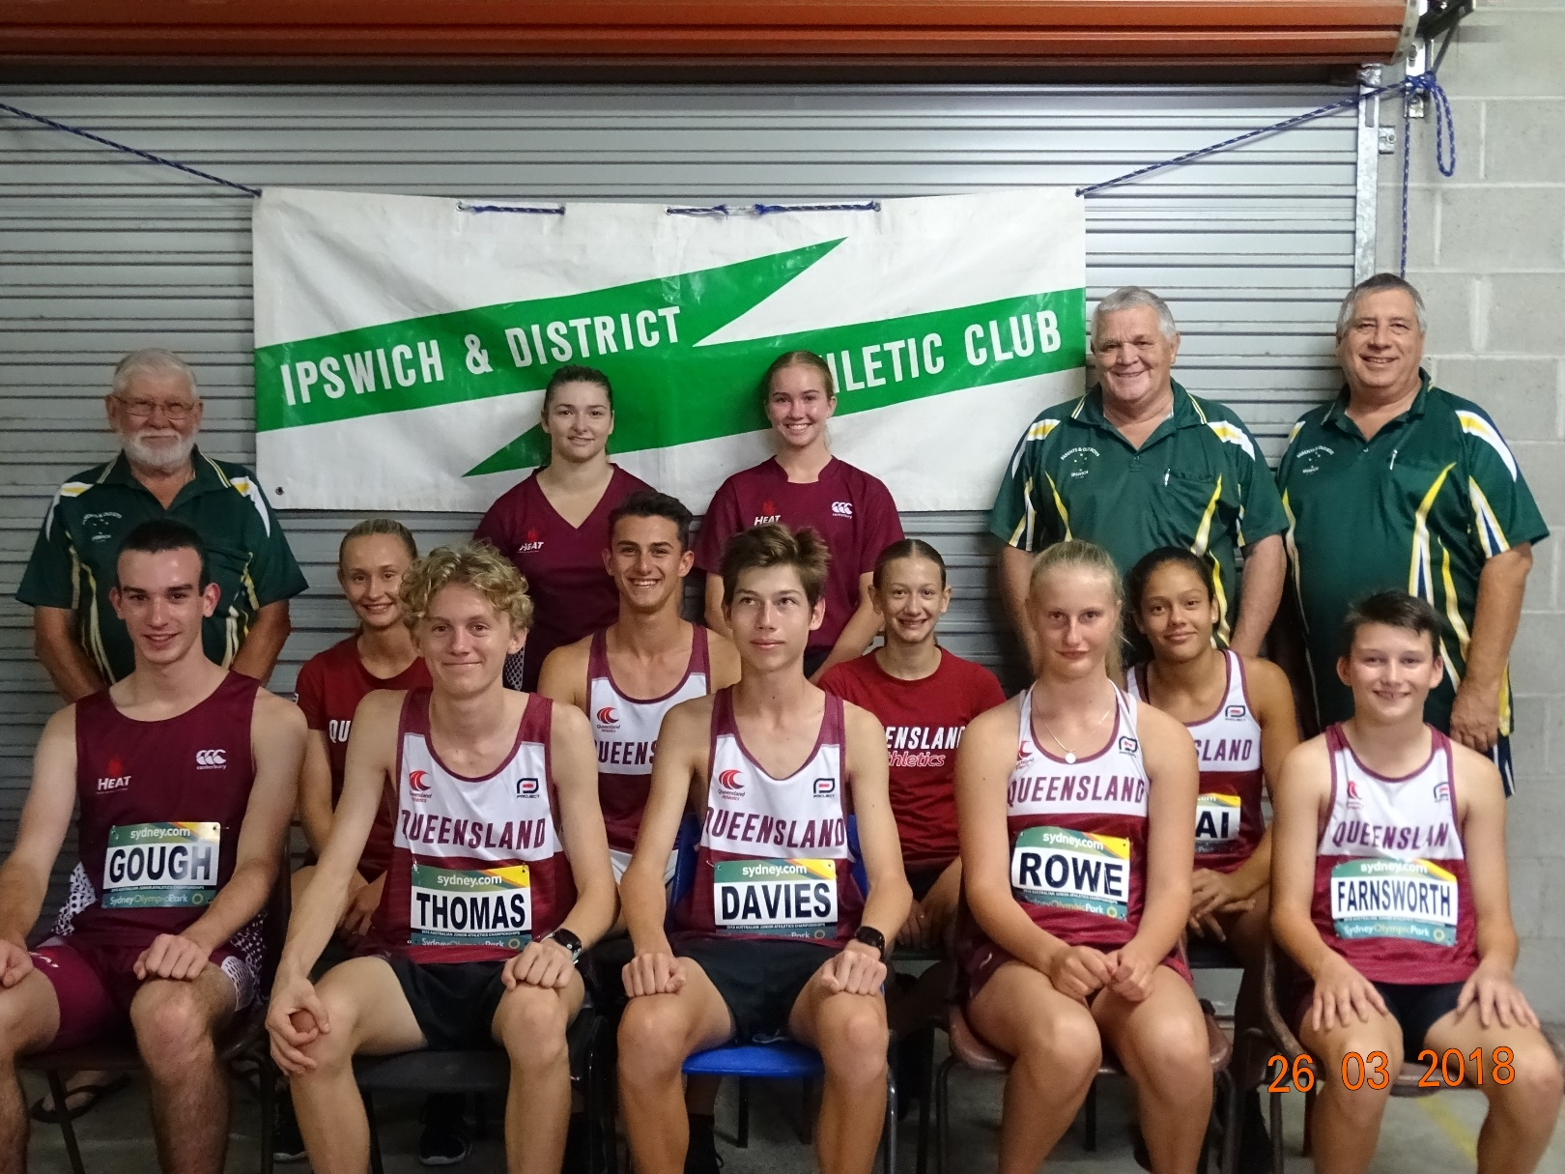

Ipswich Parents and Old Boys Association supporting our junior athletes

Committee Notes

Our next Monthly committee meeting is on Tuesday 24th April 2018 at 7pm. All welcome.

Just a Thought’

I’ve learned that…..believe you can make a difference and you will.

Track & Field InterClub Competition

All Track and Field events are now scheduled on the Queensland Athletics website

Cross country events are now available on line.

www.qldathletics.org.au

QAL now has several events scheduled on their website www.qal.org.au

Happy March Birthdays

Rochelle Vidler Kiara Condon

Jude Thomas Haley Wright

Club Uniform

The Club uniform must be worn at all interclub meets, e.g. All comers at St. Lucia, QSAC and Gold Coast etc. If the uniform is not worn, no points or performances will be recorded at inter club meets.

Answer to the Question
The winner of the February question was Jade Hardy-Synnott

The correct answer was: “Nothing.”

A new question is as follows:

Ben has never missed a single day of school, but he hasn't turned in a single homework assignment this year, either. He's always talking in class and hasn't passed a test in years.
Even so, Ben has never gotten into trouble with any school staff, even though they know full well what he's doing. Ben isn't a special student and doesn't get any unique treatment. So why does Ben never get into trouble?
Think carefully!

The first club member to reply by email with the correct answer wins a prize.

Email: - vgpascoe1@bigpond.com.au

Club Training Nights

N.B. Training sessions on a Monday and Wednesday night at the Bill Paterson oval will begin at 6.30pm and finish at 8.30pm as of the Monday 2nd April 2018 and a training fee of $3.00 will apply for each athlete.

We will be having a session, training on Easter Monday.

Any other extra training sessions can be arranged with your Coach.

A water bottle, towel and appropriate warm clothing are required for all sessions.

One Mile Gift

When: Saturday 5th May 2018

Where: Bundamba Racecourse, Ipswich.

$5,000 for the One Mile Gift

$1,000 for the 300m Gift

Entries close Friday 27th April 2018.

An Entry form is attached with this newsletter.

It is also on our website, club FB page and the QAL website.

This month’s Healthy Tip …... Foods for Anti-inflammation.

Basically, it means eating less junk that promotes inflammation and more nutritious foods that pack anti-inflammatory properties. In other words, it’s the balance of what you eat and don’t eat.

Well, since we don’t want you to starve yourself waiting to find out what you should and shouldn’t be eating, we wanted to get right to some specifics, starting with those anti-inflammatory foods, which should make up the bulk of diet. While lists are cool, keep this in mind, and you’ll be in good shape: Eat REAL food, especially plant-based foods, most of the time.

* Eat plenty of fibre. Fibrous foods support a healthy balance of gut bacteria, and fibre is typically packaged in foods that are packaged with other anti-inflammatory compounds like antioxidants, vitamins, and minerals. Fruits, vegetables, whole grains, legumes, nuts, and seeds are the best sources of fibre.
* Load up on veggies and fruits. DUH. They are packed with antioxidants (especially unique anti-inflammatory phytonutrients), which are super-important for fighting off free radicals, which are a major contributor to inflammation. Aim for 5 servings each fruits and veggies, and shoot for a wide variety of colours.
* Eat fatty fish and seafood 3 times per week. These are the best sources of the anti-inflammatory omega-3 fats. The best sources, which are also lowest in heavy metals and most sustainable, include wild salmon, Pacific sardines, rainbow trout, Atlantic mackerel, oysters, anchovies, and herring.
* Focus on healthy fats. In addition to those omega-3s from fatty fish, foods like avocados, olives, and extra virgin olive oil contain anti-inflammatory healthy fats and antioxidants. Additionally, nuts and seeds also contain healthy fats, fibre, and key micronutrients (like magnesium), which are all considered to have anti-inflammatory properties.
* Eat fermented foods. Fermented foods like yogurt, kefir, sauerkraut, pickles, and kimchi contain probiotics, which help support a healthy immune system and healthy levels of inflammation.
* Drink up. Beverages like coffee, green and black tea, and red wine are all associated with lower levels of inflammation, likely thanks to their phytonutrients, which have anti-inflammatory properties.
* Careful with carbs. You don’t necessarily need to jump on the low-carb bandwagon, but you do need to focus your carb intake on whole plant-based foods if you want to support healthy levels of inflammation. We’re talking about fruits, vegetables, tubers, nuts, seeds, whole grains, and legumes, which have a low glycaemic load and are packed with anti-inflammatory nutrients (antioxidants, fibre, vitamins, and minerals).
* Spice things up. Nearly all herbs and spices pack anti-inflammatory phytonutrients, such as flavonoids. Some of the most noteworthy anti-inflammatory herbs and spices are cocoa, garlic, ginger, oregano, pepper, rosemary, thyme, and turmeric.

Simply put, eating more of these foods will only make you feel better.

CLUB BREAKUP

Please note that the Club will hold its annual Trophy Breakup at 10.00am start on Sunday 20th May 2018 at Brothers league Club, Raceview. Many trophies are given out on this day, so please support all our members by attending.

Club Champion award

Achiever of the Year award

Les Scott Encouragement Award

Bremer Chiropractic U/20yrs award male & female

Rookie of the year award male and female

Most Interclub Participation award

Highest points for various categories and many more.

A Mystery guest speaker will be commencing the breakup, be ready with your questions!

At the breakup our Club’s Annual General Meeting will be held. All positions are declared vacant and this is your opportunity to become part of the Committee. Nomination forms for positions are available on training nights. Ph. 0409 754 884.

Queen’s Baton Relay

Current members Tara Chaplin and Molly Green had the honour of carrying the Queen’s Relay Baton today, a wonderful experience that no one will forget. Tara carried the baton at Gatton and Molly had that honour in Ipswich starting from the Ipswich State High School. Well done.
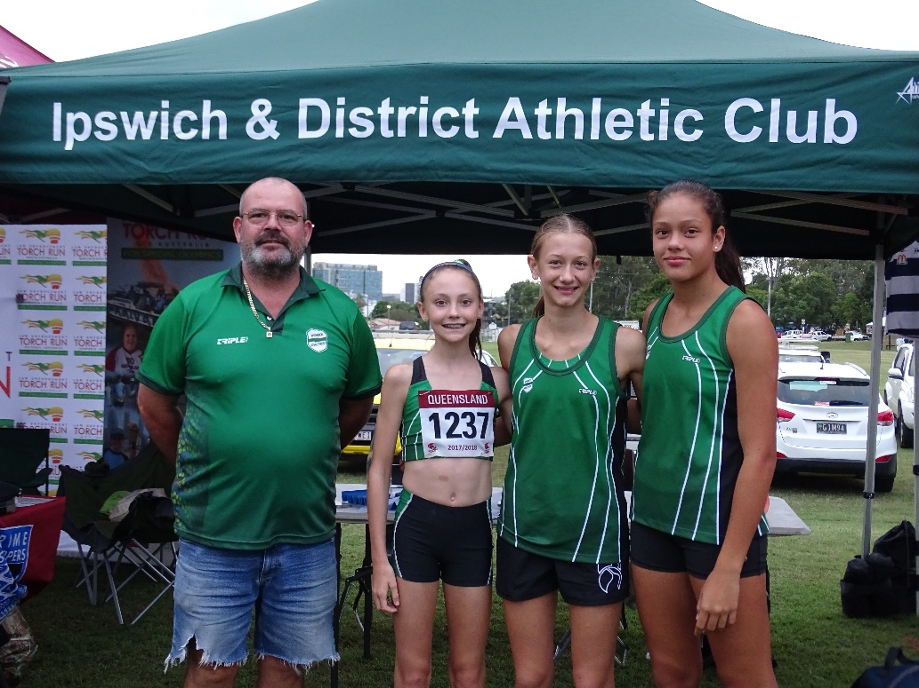

Stewart, Toby Erin & Laylani

Much needed help came from athletes and volunteers assisting with our club display at the Queen’s Baton Relay in Limestone Park. Stewart Carrick Theresa Stolberg along with Laylani Va’ai, Toby Stolberg and Erin Wright made a memorable day by showing others how to hurdle, shot put etc. They were marvelous as I believe every child and even some grownups had a go at the hurdles after our athletes showed them how it’s done, thank you girls.

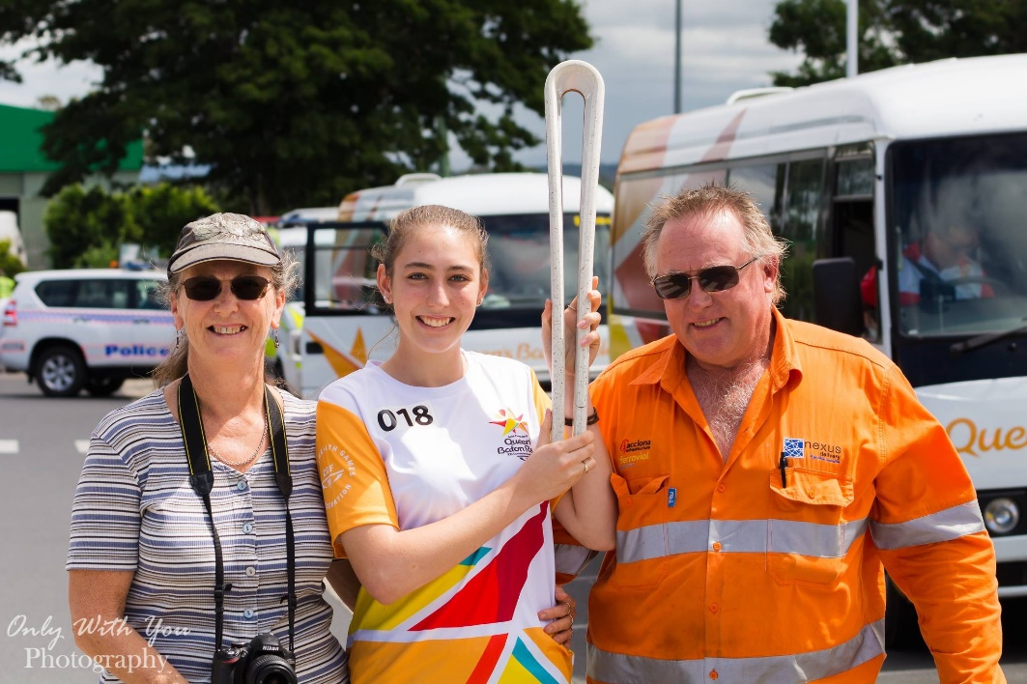

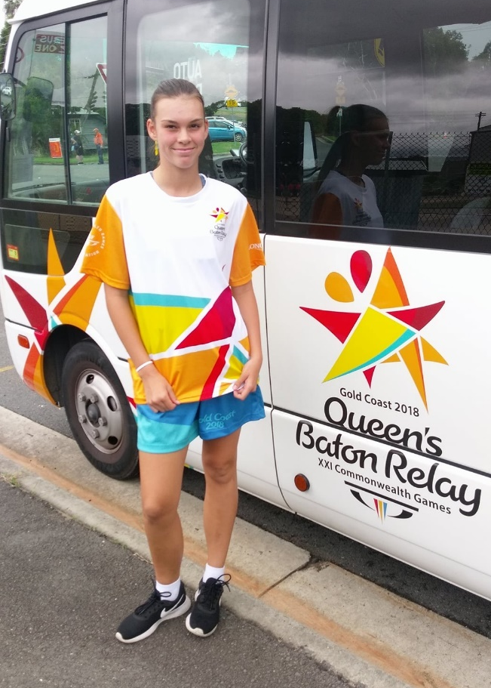

StaceyButler, Tara & James Chaplin

The look on their face says it all, how proud are we today.

Molly Green

Have a safe and Happy Easter

